# AlzheimerSoftware

# Created on May 31 2020

# Table of Contents

1.0 Inicio

2.0. Iniciar sesion

3.0. Crear cuenta

4.0. Contenido

5.0. Pantalla principal

6.0 Nivel 1. Instrucciones

# 1.0. Inicio

# 0 Imagen

Fuente: Poppins

|  |  |
| --- | --- |
| Color de fondo | #f9f6ee |
| Color café oscuro | #985428 |
| Color letra clara | #f9f6ee |
| Color letra | #153444 |
| Font size | Cursiva: 18 px  a > z :16 px  Botón: 12 px |
| Corner radious | 20 px |
| Tamaño imagen | W:218 px H: 185 px |

[https://fonts.google.com/specime  
n/Poppins?query?po](https://fonts.google.com/specimen/Poppins?query?po)

# 2.0. Iniciar sesion

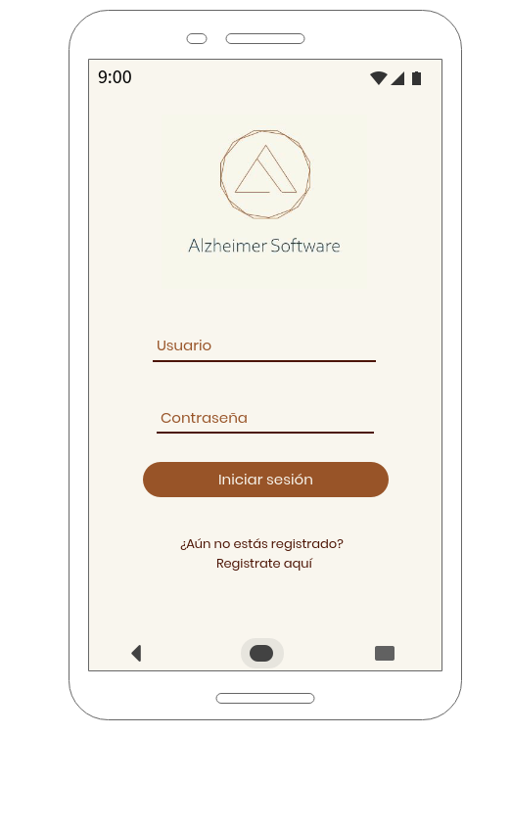

# 3.0. Crear cuenta

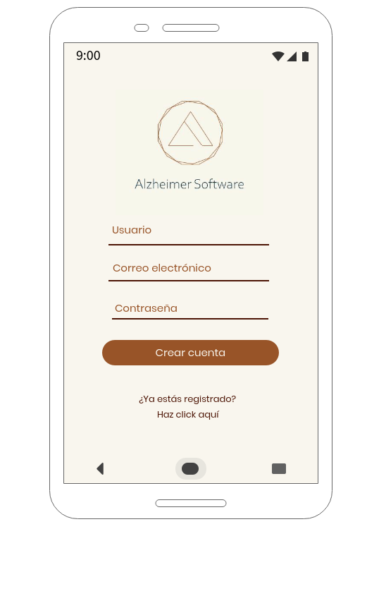

# 4.0. Contenido

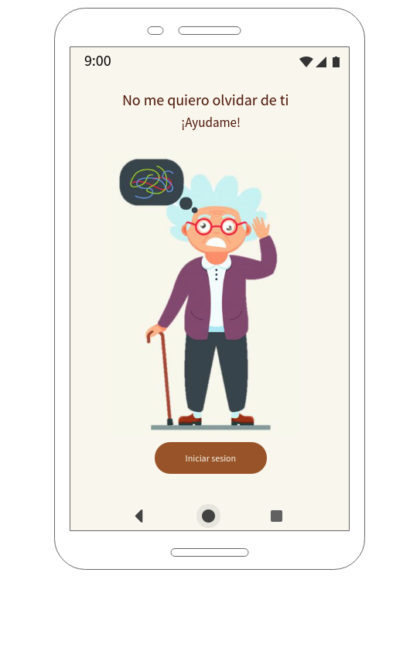

Fuente: Poppins

|  |  |
| --- | --- |
| Color de fondo | #f9f6ee |
| Color café oscuro | #985428 |
| Color letra clara | #f9f6ee |
| Color letra oscura | #4c1404 |
| Font size | Grande 20px Chica 17 px Botón 14px |
| Corner radious | 20 px |
| Tamaño imagen | W: 250 px H: 365 px |

[https://fonts.google.com/specime  
n/Poppins?query?po](https://fonts.google.com/specimen/Poppins?query?po)

# 5.0. Pantalla principal

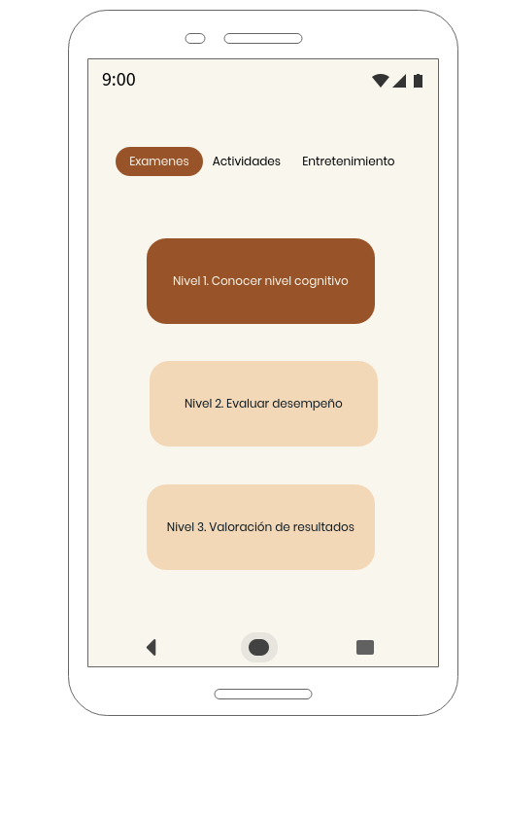

Fuente: Poppins

|  |  |
| --- | --- |
| Color de fondo | #f9f6ee |
| Color café oscuro | #985428 |
| Color café claro | #f3d8b8 |
| Color letra clara | #f9f6ee |
| Color letra oscura | #4c1404 |
| Font size | 12  Aplica en todo |
| Corner radious | 20 px |

[https://fonts.google.com/specime  
n/Poppins?query?po](https://fonts.google.com/specimen/Poppins?query?po)

# 6.0. Nivel 1. Instrucciones

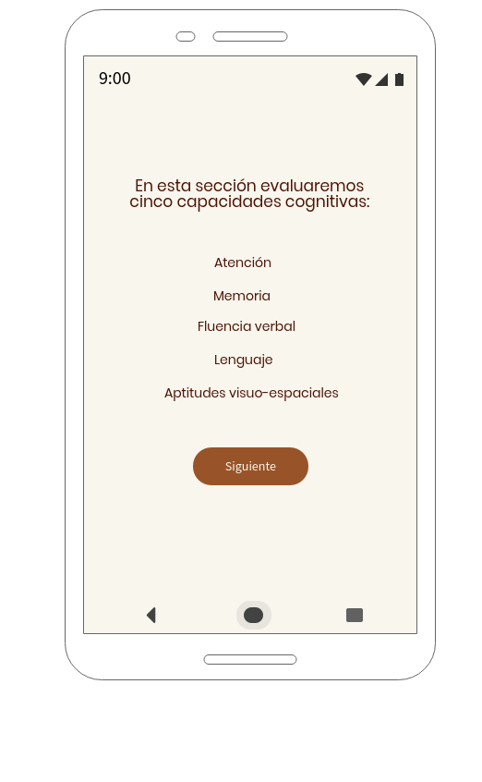

Fuente: Poppins

|  |  |
| --- | --- |
| Color de fondo | #f9f6ee |
| Color café oscuro | #985428 |
| Color letra clara | #f9f6ee |
| Color letra oscura | #4c1404 |
| Font size | 17 arriba 14 en medio  14 botón |
| Corner radious | 20 px |

[https://fonts.google.com/specime  
n/Poppins?query?po](https://fonts.google.com/specimen/Poppins?query?po)

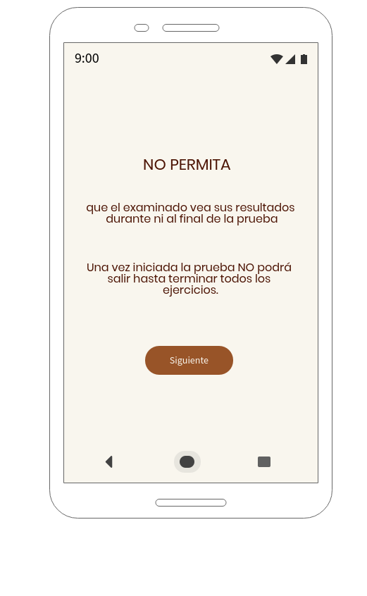

Fuente: Poppins

|  |  |
| --- | --- |
| Color de fondo | #f9f6ee |
| Color café oscuro | #985428 |
| Color letra clara | #f9f6ee |
| Color letra oscura | #4c1404 |
| Font size | 22 arriba 16 en medio  14 botón |
| Corner radious | 20 px |

[https://fonts.google.com/specime  
n/Poppins?query?po](https://fonts.google.com/specimen/Poppins?query?po)

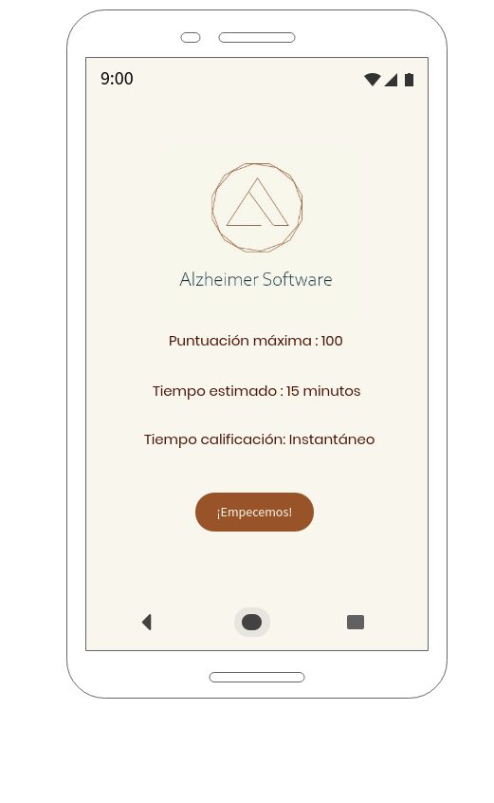

Fuente: Poppins

|  |  |
| --- | --- |
| Color de fondo | #f9f6ee |
| Color café oscuro | #985428 |
| Color letra oscura | #4c1404 |
| Font size | 15 en medio  14 botón |
| Corner radious | 20 px |
| Tamaño imagen | W: 218 px  H:185 px |

[https://fonts.google.com/specime  
n/Poppins?query?po](https://fonts.google.com/specimen/Poppins?query?po)